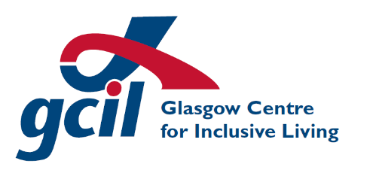
Glasgow Centre for Inclusive Living

Diversity Monitoring Form

Introduction
Glasgow Centre for Inclusive Living (GCIL) is committed to promoting equality of opportunity and treatment and to eliminating unfair discrimination in its practices. We will seek to ensure that every person is treated fairly, with respect and without bias at all times. As part of this commitment we will carry out an equal opportunities survey of our members and service users. The data collected will only be used to enable GCIL to review and report on the effectiveness of our policy, and for no other reason. GCIL needs your help and co-operation to enable us to do this, but filling in this form is voluntary.

The information provided on this form will be treated in the strictest confidence and held securely with Human Resources department.

This form asks questions relating to those grounds on which the law currently prohibits discrimination. In creating this monitoring form, we have based the questions on ethnic group and religion on the relevant questions within the 2011 Census.

All equal opportunities monitoring forms ask people to put themselves in categories. We recognise that not everyone will agree on which categories should be used in a form like this. It is also important that people are not compelled to disclose information which they would prefer to keep private. In creating this monitoring form, we have tried to take all of these issues into account as far as possible.

- Age
What is your age?
16 - 25
26 – 40
41 – 50
51 – 60
61 – 75
Over 75
I prefer not to answer this question.

- Disability
Do you consider yourself to be a disabled person?
Yes
No
If yes, which type of impairment do you have?
Hearing impairment
Learning difficulty
Mental health
Physical
Visual impairment
If you prefer to describe your impairment identity differently, please do so here:
I prefer not to answer this question.

- Ethnic Group
What is your ethnic group? Choose ONE section, then select the appropriate box to indicate your cultural background.
- African, African Scottish or African British, Caribbean, Caribbean Scottish or Caribbean British or Black, Black Scottish or Black British
African |  | Black
Caribbean |  | Other (please specify)
- Arab, Arab Scottish or Arab British
Arab
Other (please specify)
- Asian, Asian Scottish or Asian British
Bangladeshi |  | Chinese |  |  | Indian
Pakistani
Other (please specify)
- Mixed or multiple ethnic groups
Any mixed or multiple ethnic groups (please specify)
- Traveller
Irish Traveller |  | New Traveller
Roma |  | Scottish Gypsy/Traveller
Other (please specify)
- White
British |  | English |  |  | Irish
Northern Irish |  | Scottish |  |  | Welsh
Other (please specify)
I prefer not to answer this question

- Gender
How would you describe your gender?
Female
Male
Non-binary
Transgender
If you prefer to describe your gender identity differently, please do so here:
I prefer not to answer this question.

- Religion or Belief
What is your religion or belief?
No religion or belief
Church of Scotland
Roman Catholic
Other Christian (please specify)
Buddhist
Hindu
Jewish
Muslim
Sikh
Other (please specify)
I prefer not to answer this question.

- Sexual Orientation
How would you describe your sexual orientation?
Bisexual man
Bisexual woman
Gay man
Heterosexual
Lesbian
Other (please specify)
I prefer not to answer this question.

Thank you for your co-operation in completing this form.

Glasgow Centre for Inclusive Living

117-127 Brook Street Glasgow G40 3AP

Tel: 0141 550 4455

Diversity Monitoring Form – May 2018
GCIL is a charity registered in Scotland, charity number SCO24299.
Registered in Scotland – company registration 161693

